DR. KAREN REZNIK DOLINS, EdD, RD, CSSD, CDN
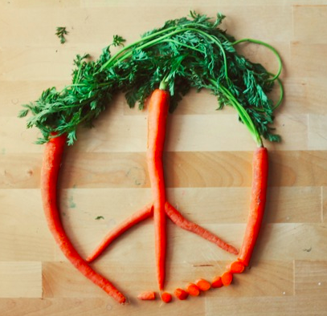
AT PEACE WITH FOOD: A HEALTHY WAY OF EATING

THE FACTS:
Those who struggle with body weight need to understand their energy needs – the amount of fuel they need for normal body functioning as well as any additional needs due to physical activity. They need to learn how to provide food (fuel) throughout the day to avoid highs and lows. Thy need to understand that eating too little is just as detrimental to body weight as eating too much. And they need to be kinder to themselves, allowing themselves to eat for pleasure as well as for nutrition.
TIPS TO ACHIEVE A HEALTHY WAY OF EATING:
- Emphasize whole grains, fresh fruits and vegetables, as they provide carbohydrates to fuel the brain and muscles along with the vitamins and minerals needed to metabolize them. In addition, the high fiber and water content of these foods make them more satisfying than more highly processed choices. Include at least 3 servings of fruit (1 medium sized or ¾ cup = 1 serving) and at least 1 cup of raw or cooked vegetables.
- Limit portion sizes and reduce mindless eating. Pay attention to when you feel satisfied, and stop eating before having a sensation of uncomfortable fullness.
- Reduce fat intake by avoiding fried and sautéed foods. Stick with grilled, broiled, or stewed dishes. Hidden fats are found in muffins, cookies, candy, and ice cream. Salads can be high in fat if the dressing is added in the kitchen. Ask for it on the side and limit to 1-2 tablespoons.
- Watch out for supersized portions of sweetened drinks. Whether it’s soda, fruit drinks, teas, coffees or lemonade, these can add hundreds of calories.
- Include low-fat dairy products for an excellent source of carbohydrates, protein, vitamins and minerals.
- Include lean meat, poultry and fish while avoiding fattier ribs, burgers, bacon and sausages. Beans can be substituted for animal sources of protein.
- Limit alcohol as it adds calories and makes mindless eating more likely.
- Always include breakfast. This meal, whether preceding a workout or work, is essential to fuel muscles and brain after an overnight fast. Going without food in the morning starts the day with an energy deficit that will result in an unfavorable hormonal response, making this meal not a place to “save” calories. Meals can be planned that are quick yet nutritious (yogurt, fruit, cereal, whole grain toast with cheese).
- Limit the amount of time that passes between meals and snacks to no more than 4 hours. For the time-challenged, (and who among us isn’t), this is often best accomplished by carrying a snack pack (home-made trail mix, dry cereal, fruit, nuts
www.nutricisedr.com info@nutricisedr.com 914.391.2982
Twitter: @nutricisedr www.facebook.com/NutriciseDr

